Viewing a Georeferenced PDF in Acrobat Adobe Reader DC
1. To view the layers in a georeferenced PDF, click on the Layers symbol to the left of the map.
2. Turn the layers on and off in the map by clicking the eye symbol to the left of the layer.
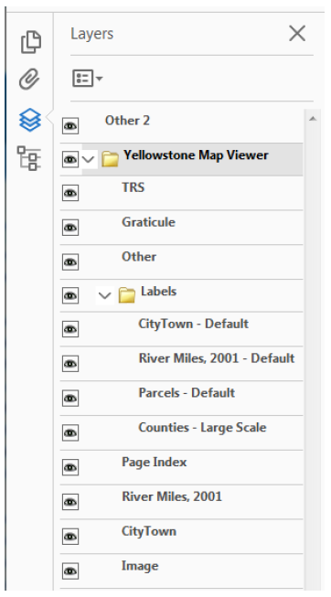

3. Access the feature attributes of each map from the lower left icon. Expand each layer to see the
sublayers, and click on a sublayer to see the attributes in the window below.
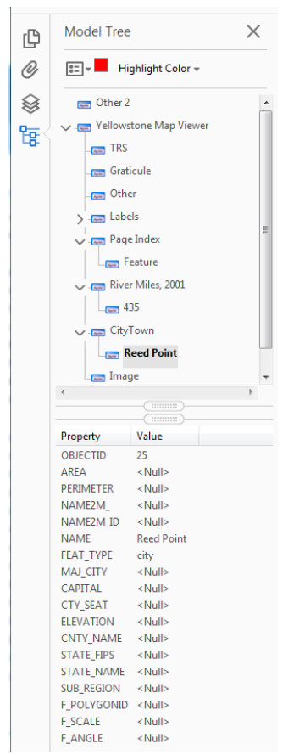
4. See the Interact with geospatial PDFs section in order to access the measuring and location tools.
https://helpx.adobe.com/acrobat/using/geospatial-pdfs.html
Import a Georeferenced PDF Into Avenza Maps Mobile App to Use in the Field

1. Download the Avenza Maps Mobile App. http://www.avenza.com/pdf-maps
2. Create an account to sign in in the app.
3. From the Home screen titled Maps, click on the + button in the lower right corner.
4. Then click on the download symbol next to Download or import a map.
5. Under Import Your Own Maps, click on From Dropbox.
6. Navigate to your Dropbox account where you have placed the georeferenced PDF to import it into the app.
7. Sign in to Dropbox and navigate to the georeferenced PDF.
8. When Avenza has completed importing your georeferenced PDF, click on it to open it.
9. If you are in the area covered by the georeferenced PDF map, your location will appear on the map as a blue icon.
10. You can drop placemarks, record GPS tracks, or measure a distance or area on your map using the tool icons at the top of the map.

Additional information on georeferenced PDFs is available here:
http://fwp.mt.gov/doingBusiness/reference/maps/geoReferencedMaps.html

