CADNSDI CUSTODIANSHIP
CORNER CORRECTION EXAMPLES AND GUIDELINES FOR CORRECTION

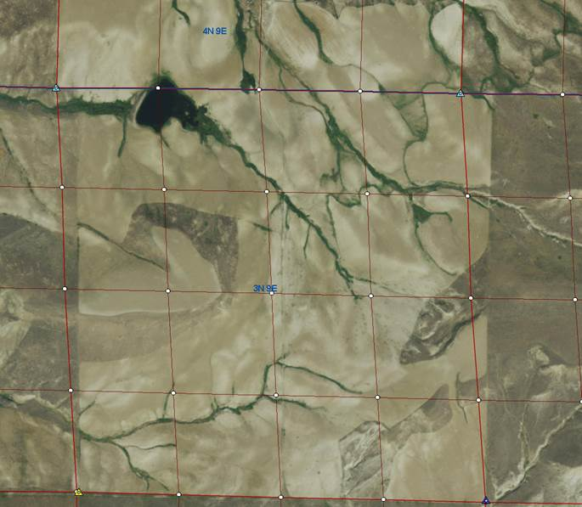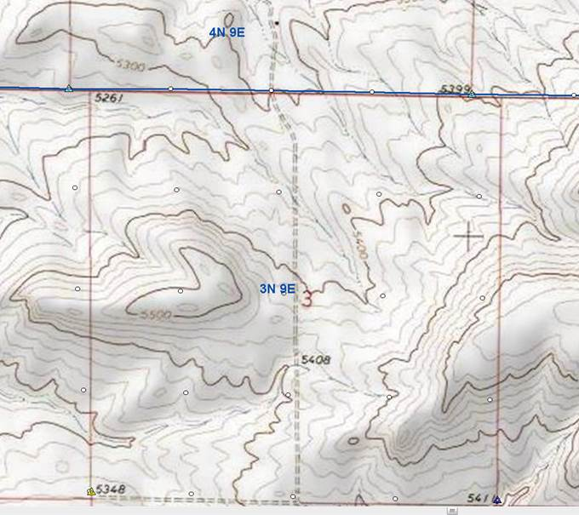

Produced by the Montana State Library in Conjunction with the Montana PLSS Change Advisory Group and the FGDC Cadastral Subcommittee – July, 1015

Introduction
In 2014 the Montana State Library (MSL), with the advice and assistance of several partner stakeholders, converted CadNSDI Version 2 from BLM to the Esri Parcel Fabric. As part of the conversion process, with the encouragement of PLSS data users in Montana and with the approval of BLM, MSL assumed the custodianship role of CadNSDI Montana. At the time MSL presumed that custodianship would consist of three primary tasks:
- Accuracy adjustments in pre-defined project areas using the best available data which may include surveyed GPS control, county corner records, photo interpreted control points and other less common data such as PLSS corner positions obtained from oil and gas permitting records.
- Entry of new survey records using the coordinate geometry tools available in GIS software. It was thought that the entry of new surveys would primarily be surveys that federal agencies conducted although private survey data could be entered if provided.
- A proactive approach to notifying users when changes to CadNSDI Montana were being planned and when they were completed. This included a well maintained website http://mslapps.mt.gov/Geographic_Information/Applications/cadnsdi/ where users could inspect active and completed projects as well as download the data and metadata. The website is augmented by frequent communications via the Montana Association of Geographic Information Professions (MAGIP) listserve and MSL’s facebook page.
As MSL gained experience using the Parcel Fabric’s adjustment tools to accomplish task one, we encountered a fourth task which was not initially anticipated. That task is the potential correction of data contained in the original CadNSDI Version 2 data that had been carried over via several iterations of Geographic Coordinate Database (GCDB) adjustments by the BLM using Geographic Measurement Management software. The source data for GCDB was the GLO plats and notes; however those data used alone without examining other potential data sources such as the USGS 7.5 minute topographic series, or aerial imagery, can cause areas of conflicting information. In fact the CadNSDI data model has a way of identifying such areas, the conflicted areas feature class, and while parcels in the database could be identified in this way, few were. Additionally simply identifying areas as conflicted does not rectify the problems, and in some areas county and state parcel databases appear questionable when these areas in CadNSDI are not fixed. In many areas both re-survey costs and difficult terrain may make total surveying solutions in these conflicted areas impractical. This paper examines the problem and puts forth some options for correcting these areas for consideration.

Conflicted Areas
Initially we will just look at three scenarios where MSL has encountered conflicting information. This section is likely to grow larger with additional examples as we move through more area adjustments. As mentioned earlier, in most cases these areas were not identified as conflicted in the original CadNSDI Version 2 database that was loaded into the Parcel Fabric, so preparing for encounters with these types of anomalies is impossible and can result in significant delays to adjustment projects as they are discovered.

Example One – Park County Montana; T4N, R9E and T3N, R9E
Here we have the case where the GLO plats, when viewed individually, don’t appear to call out offset corners as occurring with an intersecting township. Notice the two visual depictions below of the intersection of T4N, R9E and T3N, R9E; the first CadNSDI and the second the USGS 7.5 topographic series.
CadNSDI shows no offset corners while the USGS does (Appendix 1 details what we know about the USGS’s methods of locating the PLSS grid on the 7.5 map series). We welcome additional institutional knowledge about the methodology). Notice on the enlargement on the next page, how the actual land use in sections 34 and 3 seem to confirm the USGS’s depiction of the PLSS. GPS points collected by a private surveyor working for the County also confirm the presence of offsets. The question is should this type of evidence be assumed to be sufficient for the CadNSDI custodian to correct CadNSDI. In this instance, at least temporarily, MSL believes the survey evidence along with the USGS depiction warrants correction.

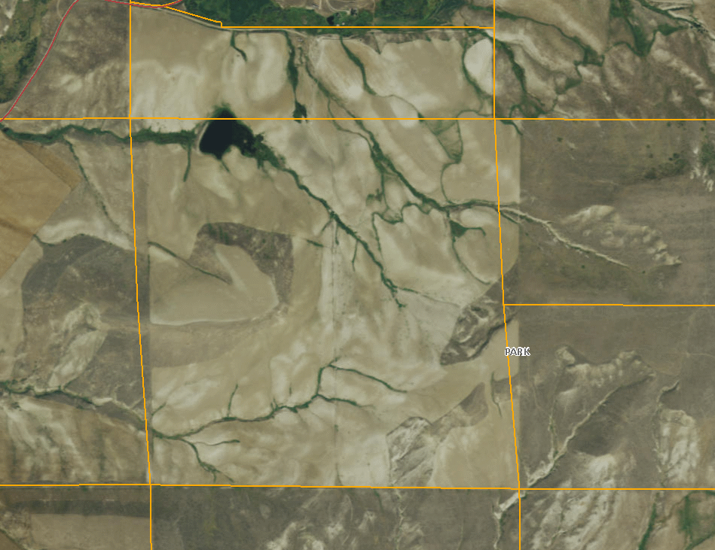
Section 34
Section 3
Landowners developed according to USGS offsets

Example Two – Park County Montana; T2N, R10E and T2N, R11E
Now let’s examine a case that has the same source data discrepancies as the first example but turned around, where CadNSDI is showing offsets and the USGS doesn’t. This particular area is between sections 18,19,30,31 of 2N, 10E and sections 13,24,25,36 of 2N, 11E.
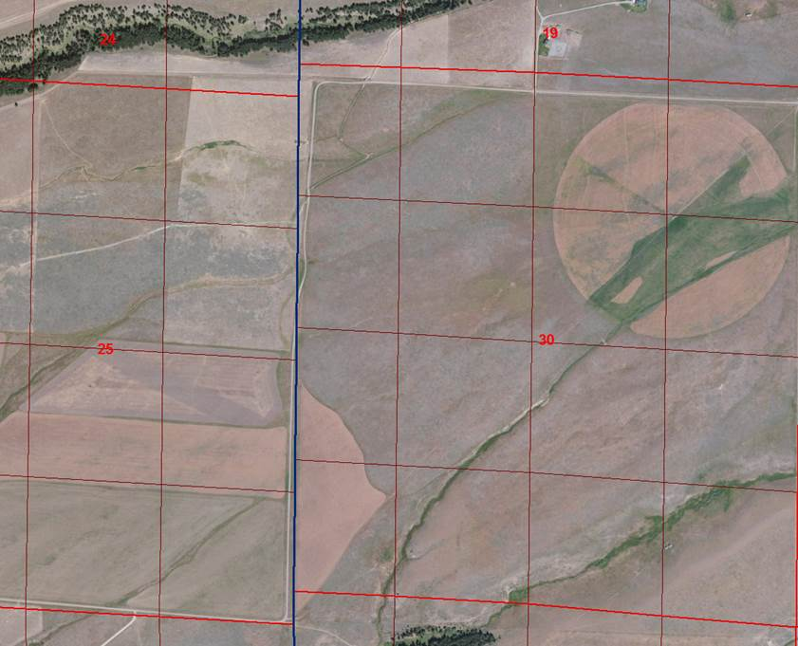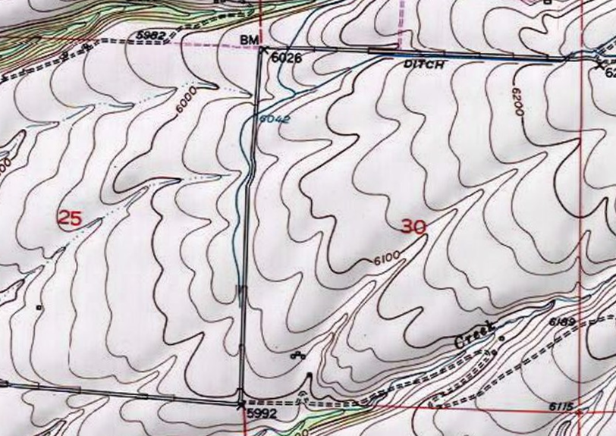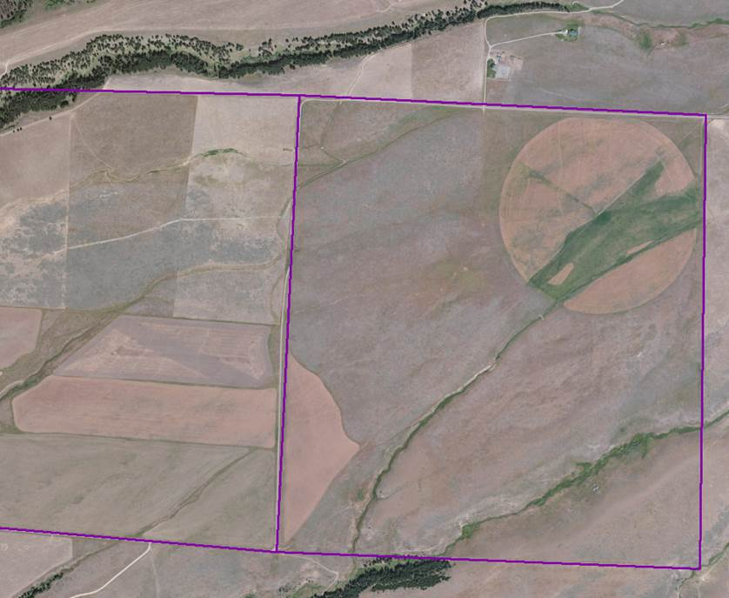
Here is the GLO Plat. The 2N 10E plat from 1905 shows an offset with the 2N 11E. Also, the Exterior township survey which includes 2N 11E shows a similar offset. The imagery and the poor reliability values on the points would lead us to believe that there is some type of survey issue going on. This area would probably be a good candidate for field verification.

T2NR10E
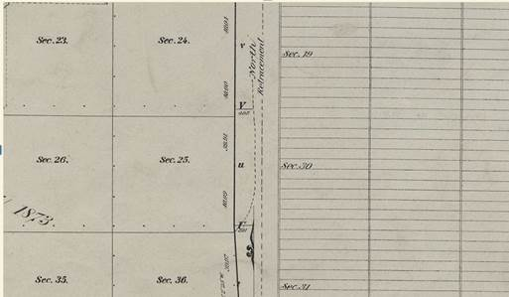
Exterior Township Survey
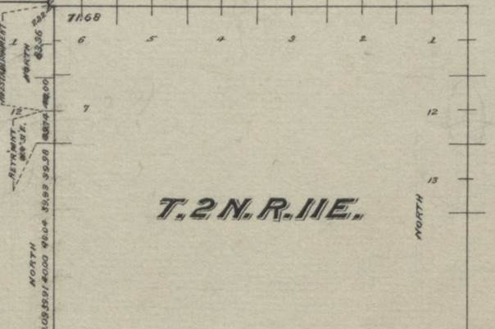

Notice how both the USGS depiction and the actual land use match and no offset is noticeable between sections 25 and 30. Again the question appears to be whether there is enough evidence to correct our GIS version of the PLSS without a total resurvey that may take years to get done unless the landowners themselves initiate it. In Montana only one remaining county has a county surveyor on staff so unless there is federal interest in the land (not in this case) or the local government can muster the resources to hire a surveyor, the position of our GIS Tax parcels, or potentially any administrative boundary coincident with the PLSS in this area, becomes of a questionable nature when displayed to the public or used in public policy decisions

Example Three – Park County Montana; T?N, R?E
For this example I need Keith to return and help me describe the situation. Keith is trying to adjust it but the data we have from the surveyor would result in such a radical shift to CadNSDI that we are unsure of what to do. This one may be truly conflicted and the answer may have to be to leave it alone. Here is what I just received from the surveyor and we will build around this.
“Yes, I know about the double corners, and would be happy to meet with Keith Blount either here or in Helena to discuss. I have reviewed some of those double corners, and while I can agree with Warren on some of his corner locations or retracements, there are some that I would agree with the first re-surveyor. Of course for the purpose of GCDB work, I did not spend an excessive amount of time researching one or two corners. Where there were alternate locations, I reviewed the work done by both the re-surveyors and went with who I thought had the most credible and correct methods.
This will probably be a controversy for many years to come with the only true resolution coming a corner at a time and being made by a court. Perhaps Keith and I can figure out a way to make it work with both corners or review the corners again and choose based on some other criteria. At any rate, all very fascinating for the surveyor but very frustrating for a landowner who may dread the appearance of a surveyor as a precursor to a once again changing property line.”
George Bornemann, PLS, CFedS
Professional Land Surveyor | Associate

Conclusions
The Montana Cadastral Database has been a work in progress for almost 20 years now. If there is anything that the past 20 years has taught us is that cadastral mapping discrepancies are seldom cut and dried with only one obvious methodology that should be employed to fix the problem. Similarly we have learned that these usually aren’t problems that can be fixed by a surveyor or a GIS analyst working in a vacuum without doing substantial research and consulting with other subject matter experts. While the nature of discrepancies encountered can be broad this discussion is focused specifically on conflicted areas needing correction in the GIS depiction of the Public Land Survey System, i.e. CadNSDI.
Before we offer up alternatives for discussion we place certain assumptions on the table for discussion
Assumption One – The conflicted areas initially attributed in CadNSDI Version 2, or new conflicted areas discovered by the CadNSDI custodian through GIS analysis, should not be blamed on malfeasance by one party or another over the years. Neither GIS nor surveying is perfect and errors occurred in the past and will occur again.
Assumption Two – There is not enough local, state, tribal or federal funds available to immediately acquire a full survey solution when CadNSDI correction areas are discovered.
Assumption Three – Solutions to most CadNSDI areas needing correction require research. CadNSDI custodianship should be supported with stable funding that allow the custodian the ability to hire and retain cadastral mapping experts who have the research skills to reach out to subject matter experts who understand the history of the area, the technical expertise to correct the problem in the most logical manner, and the interpersonal skills to communicate the changes to a variety of stakeholders.
Assumption Four – Changing the position of lines, points and polygons in CadNSDI, the digital GIS representation of the PLSS, is not likely to cause physical harm, and should not cause emotional harm to the users of the data. Incorrect or questionable positions may elicit questions from users however that is already occurring. CadNSDI custodians should be allowed a certain degree cartographic license that accompanies their professional standing as expert cadastral mappers.
With those assumptions in place we put before the cadastral community, and specifically current and potential CadNSDI custodians, the following options to discuss and determine preferred alternatives.
Alternative One – Mark the impacted parcels as conflicted in the conflicted area feature class, assuming potential correction at a later date. This is essentially the status quo position inherited from the initial CadNSDI Version 2 production.
Alternative One A -the conflicted areas could be prioritized according to the impact, cost of correction, public interest etc.
Alternative Two – research the area in a professional manner, examining all sources of data in the impacted area. If evidence and logic warrant, change the position of impacted lines, points and polygons. (Keith and Maya to expand or add other alternatives)
Alternative Three – Gain the support of policy level administrators who would allocate a funding pool to fix the areas with a full survey based solution based on priority.
Alternative Four - ????????????????????????

Appendix 1 – The USGS Methodology of Location the PLSS Grid on the 7.5 Topographic Map Series
I was a field party chief for the USGS, National Mapping Division, for roughly 13 years. My headquarters (that I was rarely in because assignments kept us party chiefs roving)​
​was the Western Mapping Center (WMC) in Menlo Park, CA. WMC moved me 32 times state-to-state amongst AZ, CA, ID, NV, OR, UT and WA but never to MT except for geodetic work along the Continental Divide. Montana & other states were under the domain of the Rocky Mtn Mapping Center (RMMC) out of Denver where I ended up as a 3rd level manager in an office position but where I was never a field party chief. WMC supposedly had different expectations of its field personnel with respect to finding, authenticating ​P.L.S.S. monuments (township corners, section corners, closing corners, & quarter corners) & putting either a photogrammetric or geodetic position on them. So what I am about to say was WMC policy which may or may not have also applied to RMMC and field procedures in Montana. Incidentally, I estimate that 40 to 65% of a WMC field party chief's efforts dealt with finding & thorough positioning of PLSS corners.
​If an original USGLO or USBLM plat was dated 1911 or later it was deemed a more modern "iron pipe township" by the USGS. What that meant was that survey methodology, instrumentation & procedures had been refined such​ that reliability of plat-shown positions was very high. Thus, in the field, we would find the 4 township corners and one section corner around Section 16, positioning them accurately, and let the office personnel in what was then called Field Surveys Inspection Section plot all of the other section corners within that township using original plat distances & bearings. The solid cross symbol shown on a USGS topo map depicts a found section corner and typically for an iron pipe survey the section lines are shown solid, even though there may not have been a found corner at the end of every section line in that township.
If an original USGLO plat was pre-1911 it was deemed a more crudely surveyed "notched rock township" by the USGS. Plat distances & bearings often had sizeable errors as to plat distances vs. factual distances between section corners, and the same thing could be said of the bearings shown by the original plat. There were often quite huge discrepancies between platted locations vs. actual locations. Also, monuments set were not iron pipe monuments but rather set stones with notches in the south face depicting how many miles the monument was from the south township line, and a number of notches in the east face depicted how many miles it was from the east township line. Because plats of notched rock townships were so much less reliable than iron pipe townships, WMC party chiefs were required to find as many of the section corners, & put a position on them, as was economically possible - many more had to be searched for than for iron pipe surveys. Many pre-1911 townships show dashed section lines on the USGS topographic quadrangle, meaning their location is in question & often does not fit the original plat. Often the only solid section lines shown on a quadrangle in this vintage township was where a section corner was found at both ends of a section line.

A couple of other factors are: Each township was typically created as an entity unto itself, and sometimes a totally different U. S. government surveyor did one township vs. an adjoining township. Also, I doubt the original surveyors laid one plat down next to the other to do "edge joins" as were done extensively on USGS quads. And closing corners typically occur along the north and west boundaries of a township but they often only depict the direction of a section line somewhere near the township line but not necessarily the intersection with the township line.

Bottom line is that original plat reliability varies widely by vintage of the original survey and, of course, if the lines in a notch-rock survey were not retraced in recent years by the USBLM & re-platted, then they still vary widely today compared to ground truthing.

So here is specifically how WMC field crews operated in positioning PLSS corners & is likely is how RMMC field crews (see what acronyms mean from my previous email) operated within Montana:

1. Original plats were provided as part of project materials the headquarters office assembled, and sometimes in problematical PLSS areas (notched rock or "pits and mounds" townships) all original field notes of the original surveyor were provided so that a field party chief assigned to particular quadrangle could know ahead of time what kind of a monument was set, and what accessories existed (like distance & bearing to scribed bearing trees, for example) in order to make his field searching for efficient.
2. In the late 1960's and early 1970's an orthophoto (all distortion of aerial photography was removed) of the entire quadrangle was provided for the field party chief so, using imagery, he/she could plot found PLSS monuments relative to imagery in order to confine search areas for other corners that needed to be found.
3. Two methods were used for photogrammetric positioning of PLSS corners:
(a) A too-scale sketch was made of the location of the monument by stereoscopic viewing in the field of overlapping aerial photos & pin pricking 3 distinct image points near the monument location. A planetable alidade with a stadia rod was used to draw on the back of the aerial photo at a much larger scale (1" = 100' or 1" = 50') the distance to the nearest foot, & directional rays, from the image points to the monument that the alidade was positioned over the top of. Later, photogrammetric stereocompilers in the headquarters plotted the 3 image points (knowns) then used the sketch to plot the corner monument position (unknown); or,
(b) Three 3' wide x 9' long "turkey leg" white polyethylene "panels", as they were called, were laid on the ground 3 feet away from the monument but the centerline of each panel was pointing at it. Later in the project the project supervisor or the individual party chief would hire a fixed wing, go up with a 35mm camera, lean out the window at near stall speed, and photograph each panel for PLSS corners & triangulation station monuments. Later, in the headquarters, a photogrammetrist would set these 35 mm pictures up in a high precision instrument that could measure to a fraction of a millimeter (micron), called a Wild PUG, which would enable the operator to look at it in 3D by changing its scale to fit, & superimposing it onto, the project aerial photography flown at a much smaller scale (higher altitude); then the Wild PUG enabled drilling the emulsion of the engineering-quality aerial photo in the exact position of the turkey-legged panel pointing at the PLSS monument.
(c) Bear in mind that at the scale of 1;24,000 feet of 7.5-minute quadrangles this degree of positional accuracy was likely overkill because the normal published line width of any symbol at that scale is about 10 feet. Both (a) and (b) above were likely exceeding that level of accuracy depending on the skills of the photogrammetrist.
4. Three methods were used for determining geodetic x, y (horizontal) and z (vertical) coordinates on a PLSS corner where topography & lack of forest enabled:
(a) Triangulation
(b) Trilateration
(c) Traverse
(d) There are orders of accuracy in the above ranging from 1st (most accurate requiring the most stringent observational procedures) through 4th. Most PLSS monuments able to be positioned with this methodology were mostly 3rd order, some were 2nd order. Remember, survey-quality GPS did not exist when the majority of the West was mapped by the USGS, and this statement likely applies to most of Montana's USGS topo quads .

I would venture a guess that because of timber canopy or topography, 60% of PLLS monuments were positioned via 3. (a), 20% were via 3. (b), and 20% were via 4.

An official monument incorrectly reset as to location by a non-licensed, non-surveyor (road excavator, utilities installer, fence builder, etc. who may have knocked the monument out of its original location) is not an authentic PLSS monument. USGS field party chiefs often had to research County records for monument descriptions to ensure authenticity both of the monument itself & its location relative to surrounding calls. If a section corner monument or quarter corner monument was of questionable authenticity in and around developed areas, as an example, this was so noted in the party chief's quadrangle diagrams & reports and that monument was not shown with the sold cross symbol on the published map.

I hope this additive info helps & does not confuse things,

P.L.S. Tony Novotny
Professional Land Surveyor-Cartographer-Broker/Owner
M.A.P.S. (Montana Allure Properties & Services), PLLC

